Anomaly Detection and Taxonomy of Smartphone Usage Behaviors

Abstract
Smartphone usage data is inherently multidimensional, capturing simultaneous behavioral signals across sleep, stress, productivity, and digital engagement. Traditional univariate anomaly detection methods—such as Z-score and IQR thresholding—fail to identify records that are individually within acceptable ranges yet collectively exhibit paradoxical or high-risk behavioral patterns. This study presents a multivariate anomaly detection and taxonomy framework applied to a synthetic smartphone usage dataset of 50,000 records. We implement an ensemble consensus strategy combining three unsupervised algorithms—Isolation Forest, Local Outlier Factor (LOF), and One-Class SVM—retaining only data points flagged by at least two of the three models. Detected anomalies are subsequently classified into three semantically grounded behavioral categories: Health-Risk, Productivity Paradox, and Behavioral Anomaly. Evaluation is performed via stability analysis, baseline comparison against univariate methods, and PCA/UMAP visualization. Our results demonstrate that the ensemble approach captures complex multi-feature inconsistencies that single-model or threshold-based methods systematically overlook, contributing a replicable pipeline for behavioral profiling in digital health contexts.
Index Terms: Anomaly detection, Smartphone usage, Behavioral taxonomy, Isolation Forest, Local Outlier Factor, One-Class SVM, Ensemble learning, Digital health.

Introduction
The proliferation of smartphones has transformed daily life, generating continuous behavioral data across sleep, stress, productivity, and digital engagement. While most analytical approaches focus on population-level averages, individuals whose behaviors are collectively anomalous—yet individually unremarkable—remain systematically overlooked. A user sleeping fewer than five hours while maintaining high productivity, or combining extreme screen time with elevated caffeine intake, represents a compellingly unusual profile that no single-variable analysis would flag [1].
Univariate methods such as Z-score normalization and IQR filtering evaluate each feature independently and are structurally incapable of detecting cross-dimensional inconsistencies. Multivariate unsupervised approaches—tree-based partitioning, density estimation, and support vector methods—offer a more principled framework for identifying records that deviate collectively from the population norm [2], [3].
This study addresses three questions: (1) How can multivariate anomaly detection identify behavioral inconsistencies that univariate methods miss? (2) Which dimensions—sleep, stress, phone usage, or productivity—most strongly drive detected anomalies? (3) How do detected anomalies relate to health risk indicators such as sleep deprivation or chronic stress?
To answer these, we implement a pipeline combining Isolation Forest, LOF, and One-Class SVM under a majority-vote ensemble strategy, followed by a rule-based taxonomy classifying anomalies into three categories: Health-Risk, Productivity Paradox, and Behavioral Anomaly. The dataset is a synthetic 50,000-record smartphone usage dataset sourced from Kaggle; all findings are interpreted within this simulated context.

Related Work
The study of anomalous behavior in digital usage data has evolved alongside the broader development of unsupervised outlier detection. Early approaches relied on univariate statistical methods—Z-score normalization and IQR filtering—which evaluate each feature independently and remain widely used for their interpretability. However, as Chandola et al. [2] demonstrate, these methods are structurally incapable of detecting inconsistencies that only emerge across multiple dimensions simultaneously, a fundamental limitation when behavioral risk is defined by the combination of variables rather than the extremity of any single one.
To address this, multivariate unsupervised methods have been developed across three principal paradigms. Isolation Forest [4] exploits the observation that anomalous instances are isolated more rapidly under random recursive partitioning, offering linear time complexity well-suited to large tabular datasets. Local Outlier Factor [5] takes a density-based approach, measuring how much a point’s local neighborhood deviates from surrounding clusters—an important capability when anomalies are context-dependent rather than globally extreme. One-Class SVM [6] learns a kernel-induced boundary enclosing normal instances, flagging those outside it as outliers. While each method captures a distinct aspect of abnormality, no single algorithm consistently dominates across dataset types [7]. This motivates ensemble consensus strategies, in which only instances flagged by a majority of detectors are retained—an approach shown to improve both result stability and semantic interpretability compared to any individual model [7].
Beyond detection, the post-hoc classification of anomalies into meaningful behavioral categories has received comparatively less attention. Nickerson et al. [8] establish a formal methodology for taxonomy construction in information systems, emphasizing that classification boundaries should be grounded in empirical data distributions rather than imposed a priori. This principle is particularly relevant in digital health contexts, where research has consistently shown that behavioral risk cannot be assessed from isolated metrics: the co-occurrence of sleep deprivation and elevated stress is a substantially stronger predictor of psychological harm than either variable alone [9], [10].
Despite these advances, the application of multivariate ensemble anomaly detection to smartphone usage data—and the subsequent taxonomy of detected anomalies into health-relevant behavioral profiles—remains unexplored. This study addresses that gap by combining a three-model consensus strategy with an empirically grounded rule-based taxonomy, producing anomaly classifications that are both statistically robust and behaviorally interpretable.

Methodology
This study adopts a multivariate, unsupervised analytical framework to identify and interpret anomalous behavioral patterns in smartphone usage data.
The dataset consists of 50,000 observations and 5 numerical features, including sleep_hours, stress_level, screen_time, productivity_score, and caffeine_intake. The data is synthetically generated to simulate realistic behavioral patterns, where individual variables fall within normal ranges but may form inconsistent combinations. No missing values or duplicate records are present, ensuring data consistency for analysis.
Unlike supervised learning tasks, the primary objective is not to predict a target variable, but to identify observations that deviate structurally from typical behavioral patterns and to interpret these deviations in a meaningful context. The methodology is therefore designed as an integrated pipeline combining preprocessing, anomaly detection, ensemble validation, and post-hoc interpretation.
Let $X∈ R^{\left\{n×d\right\}}$ denote the dataset, where each observation represents a user profile described by multiple behavioral features, including sleep duration, stress level, screen time, productivity score, and caffeine intake. The goal is to identify a subset $A⊂ X$ such that observations in $A$exhibit multivariate inconsistency, rather than extreme values in any single dimension. This distinction is central to the study, as behavioral anomalies often arise from atypical combinations of otherwise normal values.
Prior to model estimation, the dataset undergoes a preprocessing stage to ensure methodological validity. Since the selected anomaly detection algorithms rely on distance, density, or boundary estimation in feature space, all numerical variables are standardized using z-score normalization. This step ensures that features with different scales contribute proportionally to the detection process and prevents scale dominance from biasing model outputs. In addition, the dataset is verified to contain no missing values or duplicates, ensuring consistency in subsequent analysis.
Exploratory Data Analysis (EDA) is conducted to establish a baseline understanding of the data distribution. This stage includes descriptive statistics, distributional inspection, and pairwise relationship analysis among features. The purpose of EDA is not to detect anomalies directly, but to characterize the structure of normal behavior, which serves as a reference for interpreting deviations identified later in the pipeline.
To capture different notions of abnormality, the study employs three complementary unsupervised anomaly detection algorithms: Isolation Forest, Local Outlier Factor (LOF), and One-Class Support Vector Machine (OC-SVM). These methods are selected because they represent distinct modeling assumptions about anomalies. Isolation Forest is based on recursive partitioning and exploits the property that anomalous observations are more easily isolated in random trees. LOF adopts a density-based perspective, identifying observations that lie in regions of significantly lower local density compared to their neighbors. In contrast, OC-SVM defines anomalies as observations that fall outside a learned boundary enclosing the majority of the data in a transformed feature space.
The use of multiple models is motivated by the absence of a universally optimal anomaly detection algorithm. Each method captures a different aspect of abnormality, and relying on a single model may lead to unstable or method-specific results. To address this, the study implements an ensemble consensus strategy. Let $I_{m}(x_{i})∈ \{0,1\}$ denote the anomaly indicator of model $m$. An observation is classified as anomalous if at least two out of the three models agree:
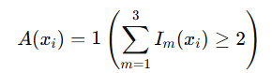
This majority-voting mechanism increases robustness by filtering out model-specific noise and retaining only those observations that exhibit consistent deviations across multiple detection paradigms.
Beyond detection, the study introduces a taxonomy construction step to improve interpretability. Detected anomalies are classified into three categories based on domain-informed rules: Health-Risk, characterized by low sleep and high stress; Productivity Paradox, defined by high productivity despite insufficient sleep; and Behavioral Anomaly, which captures residual cases that do not conform to predefined patterns. This taxonomy transforms raw anomaly labels into interpretable behavioral profiles, bridging the gap between statistical detection and real-world understanding.
To further support interpretation, dimensionality reduction techniques such as Principal Component Analysis (PCA) are applied to project the high-dimensional data into a lower-dimensional space. This allows visualization of the relative position of anomalous and normal observations, providing qualitative insights into cluster structure, boundary behavior, and the degree of separability between groups.
Since anomaly detection is inherently unsupervised and lacks ground truth labels, traditional evaluation metrics such as accuracy or F1-score are not applicable. Instead, the study evaluates the proposed framework using internal consistency criteria. These include the level of agreement among individual models, the proportion of detected anomalies relative to the dataset size, and the stability of anomaly patterns across different detection methods. In addition, interpretability is treated as a key evaluation dimension, assessing whether detected anomalies correspond to meaningful and coherent behavioral patterns.
Overall, the methodology is designed as a multi-stage analytical pipeline that integrates detection, validation, and interpretation. By combining ensemble-based anomaly detection with taxonomy construction and visualization, the study moves beyond purely technical identification of outliers and provides a structured approach for uncovering behavioral insights in multidimensional data.

Implementation and Results

4.1 Analytical Dataset
The analysis is conducted on a structured smartphone usage dataset consisting of 50,000 observations and 5 behavioral features. The dataset captures multiple dimensions of user behavior, including sleep patterns, stress levels, screen time, productivity, and caffeine consumption.
Descriptive statistics indicate substantial variability across all features. For example, sleep duration ranges from 4 to 9 hours (mean = 6.50, std = 1.45), while screen time ranges from 1 to 12 hours (mean = 6.51, std = 3.17). Similarly, productivity scores exhibit wide dispersion (mean = 55.05, std = 28.70), suggesting heterogeneous behavioral patterns suitable for anomaly detection.
Importantly, no missing values are present after preprocessing, and all features are standardized prior to model training to ensure comparability across dimensions.

4.2 Experimental Design
The anomaly detection framework is implemented using three complementary models: Isolation Forest, Local Outlier Factor (LOF), and One-Class SVM. Each model is trained independently on the standardized dataset and produces a binary anomaly label.
The final anomaly classification is determined using a majority-voting ensemble, where an observation is labeled as anomalous if at least two out of the three models agree. This design ensures that detected anomalies are robust and not dependent on a single detection mechanism.

4.3 Detection Results
The overall anomaly detection results are as follows:
- Total observations: 50,000
- Detected anomalies (ensemble): 2,180
- Anomaly ratio: 4.36%
This anomaly rate falls within a reasonable range for unsupervised detection, indicating that the model is selective and avoids excessive false positives.
A comparison across individual models shows:
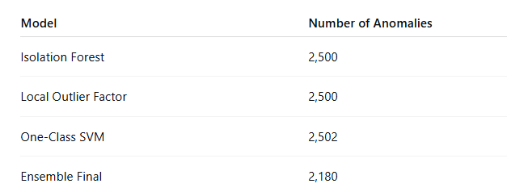
The slight variation across models reflects their different detection mechanisms, while the ensemble reduces noise by retaining only consistent anomalies.
Further analysis of model overlap reveals:
- Fully agreed anomalies (all 3 models): 698 observations
- Partial agreements (2 models): major contributors to final anomalies
- Majority of data (45,376 observations) classified as normal by all models
This confirms that the ensemble approach effectively filters out model-specific detections and focuses on structurally consistent anomalies.

4.4 Taxonomy Distribution
The detected anomalies are classified into behavioral categories as follows:
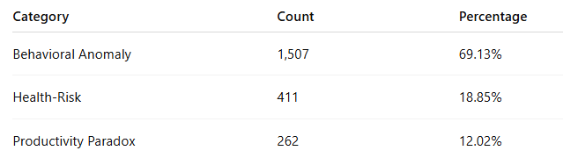
The results show that Behavioral Anomaly dominates, accounting for nearly 70% of detected cases. This suggests that most anomalies arise from complex, non-obvious feature combinations, rather than clearly defined risk patterns.
Health-Risk cases (low sleep + high stress) represent a significant minority, while Productivity Paradox cases highlight users who maintain high productivity despite insufficient rest.

4.5 Visualization and Pattern Analysis
Principal Component Analysis (PCA) is applied to reduce dimensionality and visualize anomaly distribution. The first two principal components explain:
- PC1: 20.30% variance
- PC2: 20.13% variance
Combined, they capture approximately 40.4% of total variance, providing a meaningful low-dimensional representation.
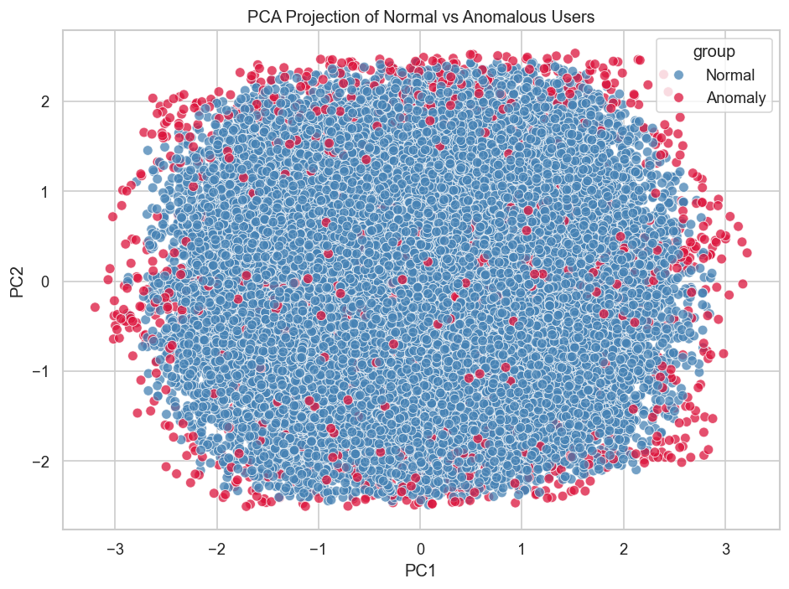
Figure 1. PCA projection of normal and anomalous users.
Visualization indicates that:
- Anomalies are partially separable from normal observations
- Some anomalies form distinct clusters
- Others lie near the boundary, representing borderline behavior
This suggests that anomaly detection captures both strong deviations and subtle inconsistencies.

4.6 Feature-Level Insights
Figure 2 compares the distributions of key behavioral features between normal and anomalous users.
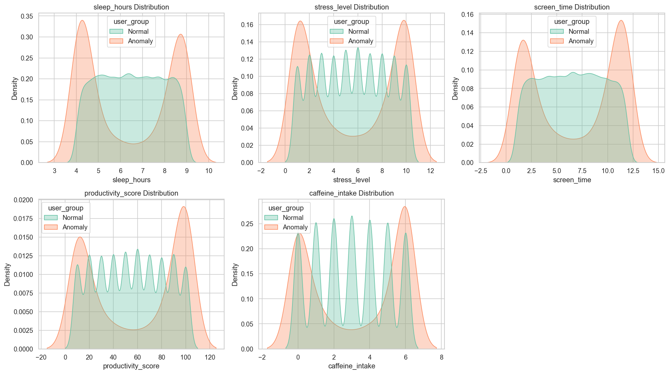
Figure 2. Distribution comparison between normal and anomalous users across key behavioral features.
Several important patterns emerge.
First, anomalous users exhibit bimodal distributions, particularly in sleep_hours and screen_time, indicating the presence of multiple inconsistent behavioral patterns rather than a single extreme condition.
Second, productivity_score is noticeably higher among anomalous users, suggesting that anomalies are often associated with elevated performance levels. This supports the presence of a “Productivity Paradox,” where high productivity coexists with irregular behavioral conditions.
Third, screen_time and caffeine_intake show a tendency toward higher values in the anomalous group, indicating increased digital engagement and stimulant consumption.
Finally, despite these differences, there is substantial overlap between normal and anomalous distributions across all features. This confirms that anomalies cannot be identified using any single variable, but instead emerge from multivariate inconsistencies.

4.7 Key Findings
Several important findings emerge from the results:
First, the ensemble framework successfully identifies a stable set of anomalies representing approximately 4.36% of the dataset, demonstrating effective filtering of inconsistent detections.
Second, anomaly behavior is predominantly characterized by complex multi-feature interactions, as evidenced by the dominance of the Behavioral Anomaly category.
Third, feature analysis reveals that anomalies are strongly associated with higher productivity and increased screen time, challenging the assumption that productivity alone indicates healthy behavior.
Finally, the relatively small differences in individual feature values confirm that anomalies are not driven by extreme values, but by subtle inconsistencies across multiple dimensions. In the absence of ground truth labels, evaluation focuses on internal consistency and structural stability. The relatively low anomaly ratio (4.36%) suggests that the model avoids over-detection, while the agreement among multiple models—particularly the 698 fully agreed anomalies—indicates that detected patterns are not random but structurally consistent. This supports the reliability of the ensemble approach in identifying meaningful anomalies.

Discussion
The findings of this study provide a deeper understanding of behavioral anomalies in smartphone usage data, highlighting that abnormality is not driven by extreme values in individual variables, but by inconsistent multivariate patterns. Across both distributional analysis and PCA visualization, a consistent observation emerges: anomalous users largely overlap with normal users in individual feature spaces, yet deviate when these features are considered jointly. This confirms that anomaly detection in behavioral data is fundamentally a problem of identifying structural inconsistency rather than magnitude-based deviation.
The PCA projection further reinforces this interpretation. Instead of forming clearly separable clusters, many anomalies are located near the boundary of the normal data distribution, suggesting that abnormal behavior often represents borderline or transitional states rather than isolated outliers. This boundary characteristic implies that anomalies may capture gradual deviations from typical behavior, which are not easily detectable using traditional threshold-based methods. In this context, anomaly detection functions less as a binary classification task and more as a tool for identifying degrees of behavioral irregularity.
A particularly notable finding is the emergence of a “Productivity Paradox.” Anomalous users tend to exhibit higher productivity scores while simultaneously displaying irregular behavioral patterns, including increased screen time and slight reductions in sleep. This challenges the common assumption that higher productivity is inherently associated with optimal or balanced behavior. Instead, the results suggest that productivity may coexist with potentially unsustainable behavioral configurations, where performance is maintained through compensatory mechanisms rather than stable routines.
Feature-level analysis supports this interpretation by showing that screen_time and sleep_hours are the most influential variables in distinguishing anomalies, while stress_level plays a comparatively weaker role when considered independently. However, the relatively small differences in mean values across features indicate that no single variable dominates the anomaly detection process. Rather, anomalies emerge from interactions among multiple lifestyle-related dimensions, reinforcing the importance of a multivariate analytical framework.
From a broader perspective, these findings carry meaningful behavioral implications. Although the dataset is synthetic and does not directly measure health outcomes, the identified patterns—particularly the combination of high screen time, reduced sleep, and increased caffeine intake—are commonly associated with imbalanced or unsustainable lifestyle behaviors. The presence of such patterns among anomalous users suggests that anomaly detection can serve as a proxy for identifying behavioral configurations that deviate from typical routines and may warrant further attention.
At the same time, it is important to emphasize that these results should not be interpreted as direct evidence of health conditions or causal relationships. The analysis identifies statistical patterns rather than underlying mechanisms. Nevertheless, in practical applications, such patterns could be used as early behavioral signals in domains such as digital well-being monitoring, productivity analysis, or lifestyle assessment. This highlights the potential of anomaly detection not only as a technical tool, but as a framework for understanding complex human behavior.
Methodologically, the use of an ensemble approach proves effective in improving robustness and reducing model-specific bias. By requiring agreement across multiple detection paradigms, the framework ensures that identified anomalies are structurally consistent rather than algorithm-dependent. This is particularly important in unsupervised settings, where the absence of ground truth labels makes validation inherently challenging.
Overall, the study demonstrates that meaningful insights in behavioral data emerge not from isolated metrics, but from the interplay between multiple dimensions of human activity. The results underscore the limitations of univariate analysis and highlight the importance of adopting multivariate, interaction-aware approaches when studying complex behavioral systems.

VI. Limitations and Future work
This study has several limitations. First, the dataset is synthetically generated and may not fully capture the complexity and variability of real-world behavioral data. Second, the absence of ground truth labels limits the ability to quantitatively evaluate detection accuracy and compare model performance using standard metrics. Third, the taxonomy is rule-based and relies on predefined thresholds, which may not generalize well across different datasets or user populations.
Future work may address these limitations by applying the proposed framework to real-world datasets, incorporating temporal dynamics to capture behavioral changes over time, and exploring more advanced models such as deep learning-based approaches to better represent non-linear interactions.

VII.Conclusion
This study presents a multivariate anomaly detection framework for analyzing smartphone usage behavior, with an emphasis on interpretability and insight extraction. By combining multiple unsupervised models within an ensemble structure, the proposed approach identifies a stable subset of anomalous observations and reveals that behavioral anomalies are characterized by inconsistent feature interactions rather than extreme values.
The analysis highlights several key findings. First, anomalies are primarily located near the boundary of normal behavior, indicating that abnormality often manifests as gradual deviation rather than clear separation. Second, the presence of a “Productivity Paradox” suggests that high performance may coexist with irregular behavioral patterns, challenging conventional assumptions about productivity and well-being. Third, feature interactions—particularly between screen time, sleep, and lifestyle-related factors—play a central role in shaping anomaly detection outcomes.
Beyond its methodological contribution, the study demonstrates the potential of anomaly detection as a tool for understanding behavioral complexity. While the results are based on synthetic data and should not be interpreted causally, they provide a conceptual foundation for applying similar approaches to real-world contexts such as digital health, user behavior analytics, and lifestyle monitoring.
Future work may extend this framework by incorporating real-world datasets, exploring temporal dynamics, and applying more advanced models capable of capturing non-linear interactions. Such extensions would further enhance the ability of anomaly detection to uncover meaningful patterns in complex behavioral systems.

References
[1] J. D. Elhai, R. D. Dvorak, J. C. Levine, and B. J. Hall, “Problematic smartphone use: A conceptual overview and systematic review of relations with anxiety and depression psychopathology,” Journal of Affective Disorders, vol. 207, pp. 251–259, Jan. 2017.
[2] V. Chandola, A. Banerjee, and V. Kumar, “Anomaly detection: A survey,” ACM Computing Surveys, vol. 41, no. 3, Art. no. 15, Jul. 2009.
[3] A. Zimek, E. Schubert, and H.-P. Kriegel, “A survey on unsupervised outlier detection in high-dimensional numerical data,” Statistical Analysis and Data Mining, vol. 5, no. 5, pp. 363–387, Oct. 2012.
[4] F. T. Liu, K. M. Ting, and Z.-H. Zhou, “Isolation forest,” in Proc. 8th IEEE Int. Conf. Data Mining (ICDM), Pisa, Italy, Dec. 2008, pp. 413–422.
[5] M. M. Breunig, H.-P. Kriegel, R. T. Ng, and J. Sander, “LOF: Identifying density-based local outliers,” in Proc. ACM SIGMOD Int. Conf. Management of Data, Dallas, TX, USA, May 2000, pp. 93–104.
[6] B. Schölkopf, J. C. Platt, J. Shawe-Taylor, A. J. Smola, and R. C. Williamson, “Estimating the support of a high-dimensional distribution,” Neural Computation, vol. 13, no. 7, pp. 1443–1471, Jul. 2001.
[7] G. O. Campos, A. Zimek, J. Sander, R. J. G. B. Campello, B. Micenková, E. Schubert, I. Assent, and M. E. Houle, “On the evaluation of unsupervised outlier detection: Measures, datasets, and an empirical study,” Data Mining and Knowledge Discovery, vol. 30, no. 4, pp. 891–927, Jul. 2016.
[8] R. C. Nickerson, U. Varshney, and J. Muntermann, “A method for taxonomy development and its application in information systems,” European Journal of Information Systems, vol. 22, no. 3, pp. 336–359, May 2013.
[9] M. Walker, Why We Sleep: Unlocking the Power of Sleep and Dreams. New York, NY, USA: Scribner, 2017.
[10] J. D. Elhai, H. Yang, D. McKay, and G. J. Asmundson, “COVID-19 anxiety symptoms associated with problematic smartphone use severity in Chinese adults,” Journal of Affective Disorders, vol. 274, pp. 576–582, Sep. 2020.

